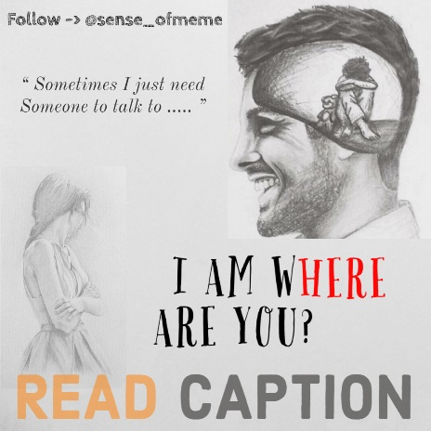

Have you ever felt that you want to talk to someone? You go to the contacts app on your phone and scroll through all of them. Then, you decide to put your phone away and lie down on your bed with lights off.  
  
Loneliness affects almost everyone at least once in his or her life. It can be experienced in a crowd, with friends, with family, or even with your loved ones. Loneliness can be traced back to low self-esteem.  
  
Chronically lonely people will usually have low opinions of themselves. They may think of themselves as unintelligent, unattractive, broken, unwanted, not worthy of good things, unable to do anything right, and/or socially isolated. They pay more attention to negative social information like disagreement or criticism. They remember more of the negative things that happened during an encounter with another person and fewer positive things. Loneliness can cause people to feel depressed, empty, unwanted, and alone.  
  
We need to support such people by interacting with them and making them feel comfortable around us. Like, with a person who feels particularly unloved and unwanted, someone close to them should try to take a little extra time to spend with that person and try to set aside a little extra time to talk to the person. Nothing special needs to be said or done, simply spending time, willingly and without having been asked, allows the lonely one to see that they are loved.  
  
As you try to do the above mentioned activity, then you’ll actually work to boost someone’s self confidence making them value themselves more and believe that they are always worthy of love even though they are alone.   
  
Truth is, everyone needs time to figure out themselves, gather their thoughts, and just totally chill out. Your life has many precious moments which are very important for your own peace of mind and mental refreshment.  
  
So, learn to embrace loneliness and just remember you’re worthy of love !  
  
____________________________________  
  
Penned By✍️ :  
👉 [@sense_ofmeme](https://www.instagram.com/sense_ofmeme/) x [@utka_rsha](https://www.instagram.com/utka_rsha/) 👈  
  
____________________________________  
  
Do Like - Share - Follow [@sense_ofmeme](https://www.instagram.com/sense_ofmeme/) 😉  
  
____________________  
  
For Collab :  
👥 Contact Sense of Meme (Admin) via DM or Email .